# My Organism Preferences

***Note:*** *this exercise uses VEuPathDB.org as an example database, but the same functionality is available on all VEuPathDB resources.*

**Learning objectives:**

* Navigate to the My Organism Preferences page
* Set your organism preferences
* Enable and disable the My Organism Preferences tool

The My Organism Preferences feature allows you to cherry-pick any combination of organisms you might be interested in. Enabling this feature applies your organism preferences globally across the site, resulting in a filtered view to help focus your work. Search menus and tools will reflect only your chosen organisms and only search data associated with your chosen organisms. The goal of this exercise is to set your organism preferences to include Apicomplexa and Oomycetes and exclude all other organisms in the database.

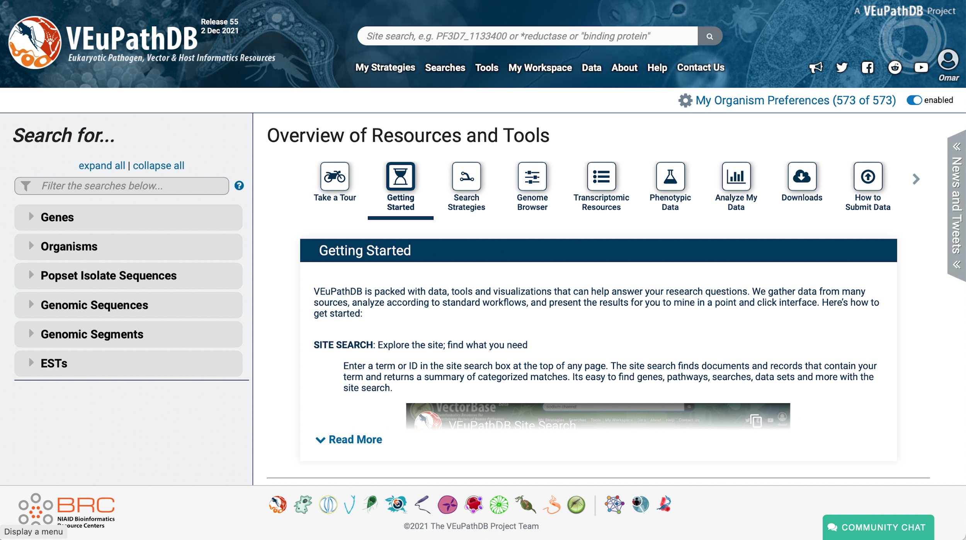

1. Navigate to “My Organism Preferences” link at the top right of the page.
   1. The next page displays the current organism preferences selection. If you haven’t set these preferences before you should see all VEuPathDB organisms chosen by default.
   2. Click on the clear all option, then select the Apicomplexa and Oomycota checkboxes. Notice that the panel on the right updates automatically with your selection from the left.
   3. Once you are satisfied with your selection, click on the Apply button to activate your organism preferences.

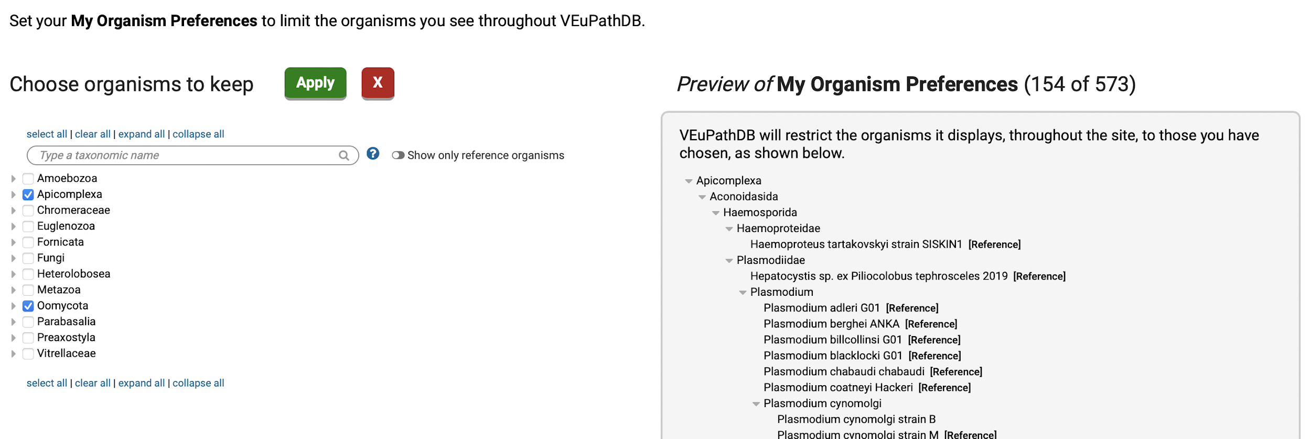

1. Explore how the My Organism Preference affects your experience on VEuPathDB. For example, navigate to the “RNA-Seq Evidence” search page. Click on the searches menu item then search for RNAseq. Next click on the RNA-Seq Evidence to go to that search page. Examine the available datasets. They should all be from organisms set in your preferences.

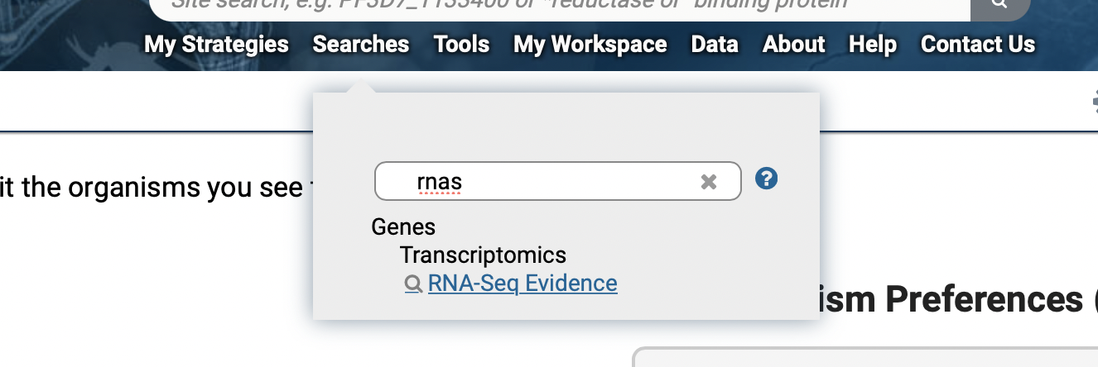

1. Try toggling the “My Organism Preferences” switch (hint, just click on it to deactivate or activate). What happens to the list of datasets?

